SANA Area Meeting Minutes
Date: May 2026
Location: Area Service Meeting
Time: 2pm

Opening
- Meeting opened with readings:
  - 12 Traditions of Narcotics Anonymous
  - 12 Concepts of NA Service
  - AREA Purpose Statement
- Followed by acknowledgements and transition into open forum.

Open Forum (15 Minutes)

Key Topics Discussed:
- Decline in Meeting Attendance
  - Many groups struggling to maintain participation.
  - Post-COVID attendance has not fully recovered.
  - Some meetings have closed due to lack of support.
- Outreach & Engagement
  - Importance of visiting and supporting other groups emphasized.
  - Encouragement to announce open service positions at home groups.
  - Suggestion to involve newer/younger members in service.
- Meeting Formats
  - Discussion around effectiveness of:
    - Literature-based meetings vs. topic discussions
  - Literature meetings appear more stable and better attended.
- Public Relations & Accessibility
  - Need for stronger PR efforts identified.
  - Concerns about stigma toward individuals on medication-assisted treatment.
  - Decline in court-mandated attendees noted.
- Ideas for Improvement
  - Area inventory or workshop to evaluate effectiveness.
  - Increase variety in meeting formats.
  - Reintroduce outreach tools like meeting lists in community locations.

Service Position Updates

Open/Vacant Positions:
- Vice Chair
- Alternate RCM
- H&I Chair
- PR Chair

Newly Filled / Active:
- Treasurer (transition in progress) – Kim A
- Policy Chair – Mike M

Home Group Roll Call
- Approximately 12 groups listed
- Roughly 50% attendance representation
- Present were Solutions, Living Clean, Recovering Vigilantes, The Steps are the Solution, Survivors,

Reports

RCM Report
- Attended Regional Service Assembly (Martinsburg, WV)
- Topics included:
  - What makes an effective/attractive area
- Open regional positions:
  - Vice Chair, Vice Treasurer, Policy, PR
- Donations reported:
  - Southside: $200
  - Living Clean: $75 (Area), $50 (Region)
- Upcoming:
  - October GSR Assembly planning underway

Literature Report
- Orders received and distributed to home groups
- Inventory stable

Activities Report
- Request: $305 for upcoming event (May 16, 12–6 PM)

Group Reports Highlights
- Living Clean: 9–12 attendees weekly; new member added
- Recovering Vigilantes: Strong attendance; multiple anniversaries; $119 donation
- Solutions with Serenity: Attendance improving; $10 donation
- Survivors: Attendance struggling; $20 donation
- Steps to Solution: Small but steady; $45 donation

Old Business

Activities Funding Request
- Motion to provide $305 for upcoming event
- Vote Results:
  - 2 Yes / 3 Abstain
- Motion Passed

New Business
- Meeting lists:
  - Available for distribution
  - Proposal to improve meeting list design (add QR codes, event info, messaging) Kim is willing to do it if Kaylee approves

RCM Gas Reimbursement
- Request: $107.14
- Policy allows: $50
- Motion made to:
  - Reimburse full amount ($57.14 over policy)
  - Send to home groups for vote next month
- Paste Motion Here. – Motion goes to Homegroups for vote

Treasurer’s Report

- 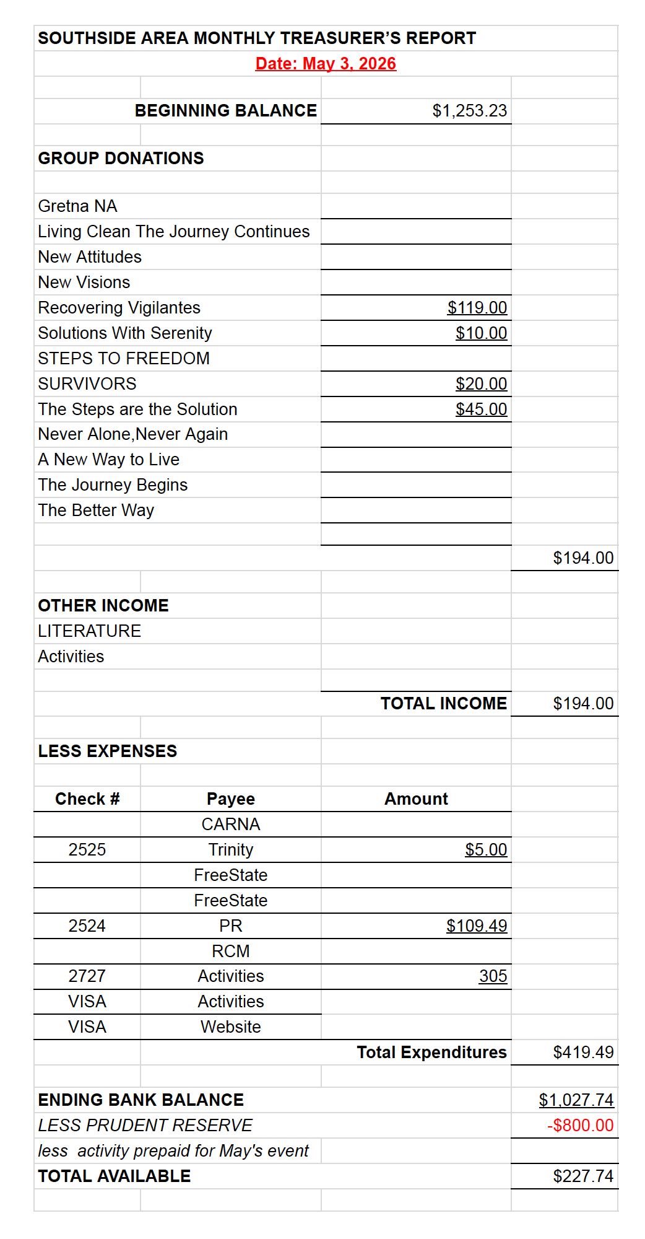

Vote:
- Treasurer’s report approved (5–0–0)

Additional Discussion
- Need to:
  - Update budgets annually (last major update noted from 2018)
  - Improve financial tracking and transparency
- Ideas for:
  - Digital meeting lists (QR codes)
  - Better use of printed materials for outreach

Next Meeting
Date: June 7, 2026

Closing
- Motion to close made and accepted
- Meeting adjourned

Notes taking by voice recording, transcribed by AI submitted by Kim A

